84.04.25
From Ellie Bauer
RB MSS M64, Library, Royal Botanic Gardens Melbourne.

April 25th 84
Baron Von Mueller

Dear Sir,
I am sending you a few more specimens by this boat & I hope they will arrive in better condition than the last.
No. 45. I have had drying over a month, but it seems just as fresh as the day I picked it. It grows along the sea shore — is a creeper, has no leaves & has a milkly sap — Its flower is diminutive & white resembling hoiya (?). It looks much like an orchid.
No 49 Is a specimen of the spiral tree I mentioned in last letter. The flowers Ive sent are last years ones. Those of this year being only in bud now — Ive also sent you the notch out of which the flowers come

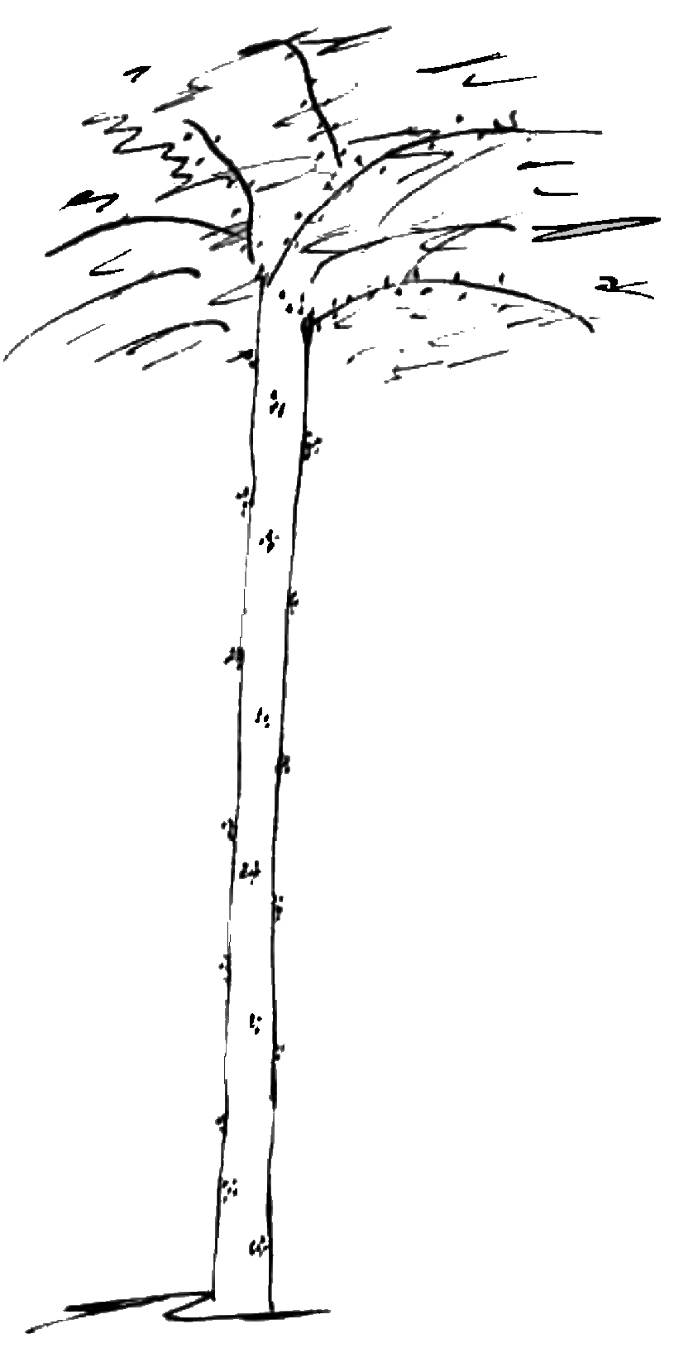 | These notches grow out of the stem in a left-handed spiral all up the tree & continue along the branches even — The flowers are white & feathery & when in full bloom join the flowers on the next notch & thus form a complete spiral all up the tree. If the flowers Ive sent are too old, I can send you some new ones. I think they will be in full bloom in about three weeks.
No 46 is a red pod, found in the scrub. But I could not find the tree or vine it came off. It smells very like a granadilla & the seeds are not unlike granadilla seeds
47 — a piece of wood with a very yellow sap — The wild bees seem very fond of the sap — Could not get at the leaves of the tree as it was mixed up in a felled scrub.
48 a red flower with yellow centre, flower grows straight out of the ground & has no appearance of leaves about it. If it is new I will try & get its leaf. They say it has one, but it does not grow up near the flower.
50. Strongly scented wood. When first cut the scent is almost too strong.
Have not seen the tree so could not get leaves or flowers —
The Malays seem to prize it.
If no. 49. the tree with the spiral is new please name it after my father. As he was the first to discover it.
I am pleased to hear that among the plants I sent you, you have found one new one viz: — the creeper with the fruit like a lime. I shall much like it to be named after me. I cannot send you the flower of it yet for I think it must have done flowering, but when it does I'll get you some.
You did not mention the names of all the plants I sent, but I suppose some of them arrived in too bad a condition, to be recognized.
Believe me
yours truly
Ellie Bauer

MS found with a specimen of Sarcostemma australe (MEL 1606654), collected at Bloomfield River, Qld. MS annotation by M: 'Answ 6/5/84, FvM'. Letter not found.
Original sketch 12 cm high.

